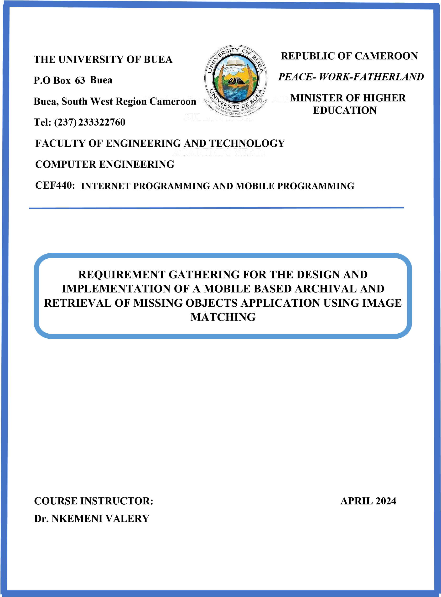

PRESENTED BY: **By Group 21**

| **S\N** | **NAME** | **MATRICULE** |
| --- | --- | --- |
| 1 | AKENGNI KEANLI EMMANUEL | FE21A132 |
| 2 | CHOMOH SYLVIA FONCHENALLAH | FE21A162 |
| 3 | MBI AYAMBA DIANNA | FE21A230 |
| 4 | NGAUEN NDJOMOU LOICE VANELLE | FE21A258 |
| 5 | NGOBA STEVE JONES NTONSG | FE21A259 |

TABLE OF CONTENT

**LIST OF FIGURES 3**

**1.** **INTRODUCTION 4**

1.1 PROBLEM STATEMENT 4

1.2 PROJECT GOALS 5

1.3 PR0JECT SCOPE 5

**2.** **REQUIREMENT GATHERING 5**

2.1 IDENTIFYING STAKEHOLDERS 6

2.2 GATHERING ESSENTIAL INFORMATIONS: 6

*2.2.1* *INTERVIEW: 6*

*2.2.2* *ONLINE SURVEY: 8*

2.3 COMPETITOR ANALYSIS 9

*2.3.1* *EXISTING SYSTEMS LIMITATIONS 10*

*2.3.2* *IMAGE MATCHING TECHNOGOGIES: 10*

*2.3.3* *STAKEHOLDERS NEEDS AND EXPECTATIONS 12*

**3.** **SYSTEM REQUIREMENT 13**

3.1 FUNCTIONAL REQUIREMENT 13

3.2 NON FUCTIONAL REQUIREMENT 14

**4.** **IMPORTANCE OF REQUIREMENT GATHERING 15**

**5.** **CONCLUSION 15**

**6.** **REFERENCES 16**

# LIST OF FIGURES

Figure 1: steps of requirement gathering

Figure 2: an overview of image Hashing

Figure 3: an overview of template matching

# INTRODUCTION

In today's digital age, mobile technology plays a crucial role in enhancing our daily lives and solving complex problems. One such challenge is the retrieval and archival of missing objects, a common issue that affects individuals and communities worldwide. The development of a Mobile-Based Archival and Retrieval of Missing Objects Application using Image Matching aims to address this problem by leveraging advanced image recognition technology to assist users in locating lost or stolen items efficiently. This approach harnesses the ubiquity of smartphones and advances in image recognition to create a practical solution for retrieving missing items.

## PROBLEM STATEMENT

Every year, countless personal items are lost or stolen, causing not only significant financial loss but also personal inconvenience and emotional distress to individuals.

Traditional methods of locating missing objects often rely on manual searches or centralized databases, leading to inefficiencies and delays in retrieval. There is a need for a more streamlined and accessible solution to aid in the swift recovery of lost items.

In the digital era, there is a critical need for a more dynamic and technologically advanced solution that can offer a higher rate of recovery with less effort and time. Existing digital solutions fail to fully exploit the potential of modern technologies like image recognition, which can significantly enhance the process of identifying and matching found items with their rightful owners.

The objective of this project is to design and implement a user-friendly mobile application that enables users to upload images of missing objects and search through a database of found items using image matching algorithms. This technology promises not only to enhance the probability of recovering lost items but also to streamline the process, making it quicker and more efficient .

## PROJECT GOALS

▪ To create an easy-to-use mobile platform that allows users to upload images of lost or found objects.

▪ To use image matching technology to automate the comparison of newly uploaded images against existing entries in a robust database.

▪ To enable users to communicate securely and coordinate the return of objects.

## 1.3 PR0JECT SCOPE

This report explores the development and implementation of a Mobile-Based Archival and Retrieval of Missing Objects Application using Image Matching technology. It delves into the functionalities of the proposed application, examining how image matching algorithms can be leveraged to efficiently locate lost items. Additionally, it investigates potential use cases across various sectors, such as transportation, hospitality, and personal belongings. Furthermore, the report assesses the effectiveness and feasibility of the proposed solution in comparison to traditional methods of object retrieval.

# REQUIREMENT GATHERING

For a successful design and implementation of a Mobile-Based Archival and Retrieval of Missing Objects Application using Image Matching, the requirement gathering process is crucial. This process will guide the development of an application that efficiently serves the needs of users wanting to find their missing objects using image matching technology. This phase is critical as it directly influences the scope, design, functionality, and overall success of the application. Here is a detailed breakdown of the requirement gathering process for this project:



*Figure 1: Steps of requirement gathering*

## IDENTIFYING STAKEHOLDERS

This step involves listing all parties who might have an interest in or be affected by the mobile app. By brainstorming, we identified the following stakeholders:

* End Users: Individuals who will use the app to find missing objects.
* Contributors: Users who may upload images of found objects.
* Law Enforcement: If the app will be used for stolen objects, police and other law enforcement agencies might be involved.
* Legal and Compliance Experts: To address data privacy issues, especially related to uploading personal data and images.
* Developers and Technical Staff: Those who will develop and maintain the app.
* UI/UX Designers: Specialists in user interface and user experience design.
* Data Scientists: Experts in image recognition and matching technologies.
* Marketing Team: To promote the app and ensure it reaches a wide audience.
* Investors and Sponsors: If external funding is involved.
* Community Organizations: Local groups interested in property safety or community services.

## GATHERING ESSENTIAL INFORMATIONS:

Gathering essential information for a mobile-based application that uses image matching technology for the retrieval and archival of missing objects involves collecting critical data and insights across multiple dimensions. This foundational step ensures the app's functionality aligns with user needs, technological capabilities, and market expectations. We gathered our informations by conducting interviews, surveys and competitor analysis.

### INTERVIEW:

This is a qualitative research method used to gather in-depth information from potential users, stakeholders, experts, and other relevant parties. We conducted interviws with a series of questions.Here's a detailed look at how interviews the interview was structured and the out comes;

#### INTERVIEW QUESTIONS

* How often do you misplace or lose important items?
* Which types of items do you commonly misplace or lose?
* Have you used any similar apps or solutions for finding lost items before? If yes, please specify.
* What features would you expect from an app designed to help you find missing objects using image matching?
* How comfortable are you with using technology to track and locate your belongings?
* What devices do you primarily use for such tasks (e.g., smartphone, tablet, computer)?
* Would you be interested in receiving notifications or alerts when an item is detected using image matching?
* How important is accuracy in locating missing items for you?
* Are you concerned about the privacy and security of your data while using such an app?
* Would you prefer a free app with ads or a paid app without ads for this purpose?
* Do you have any suggestions or specific features you would like to see in this app?
* We obtained the following answers from the interview:

#### INTERVIEW RESULTS

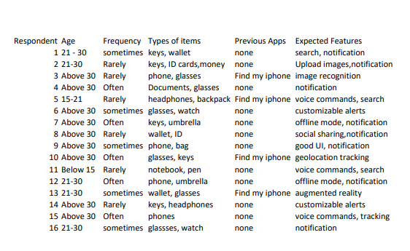

### ONLINE SURVEY:

An online survey is a research tool used to collect data from a large group of people about their needs, preferences, behaviors, and perceptions. This method is particularly valuable for gathering quantitative insights from a wide audience quickly and efficiently. We conducted the online survey with a series of question and we obtained the following result:

We have **27 person** who are filled the form

* concerning the person who lost an Items

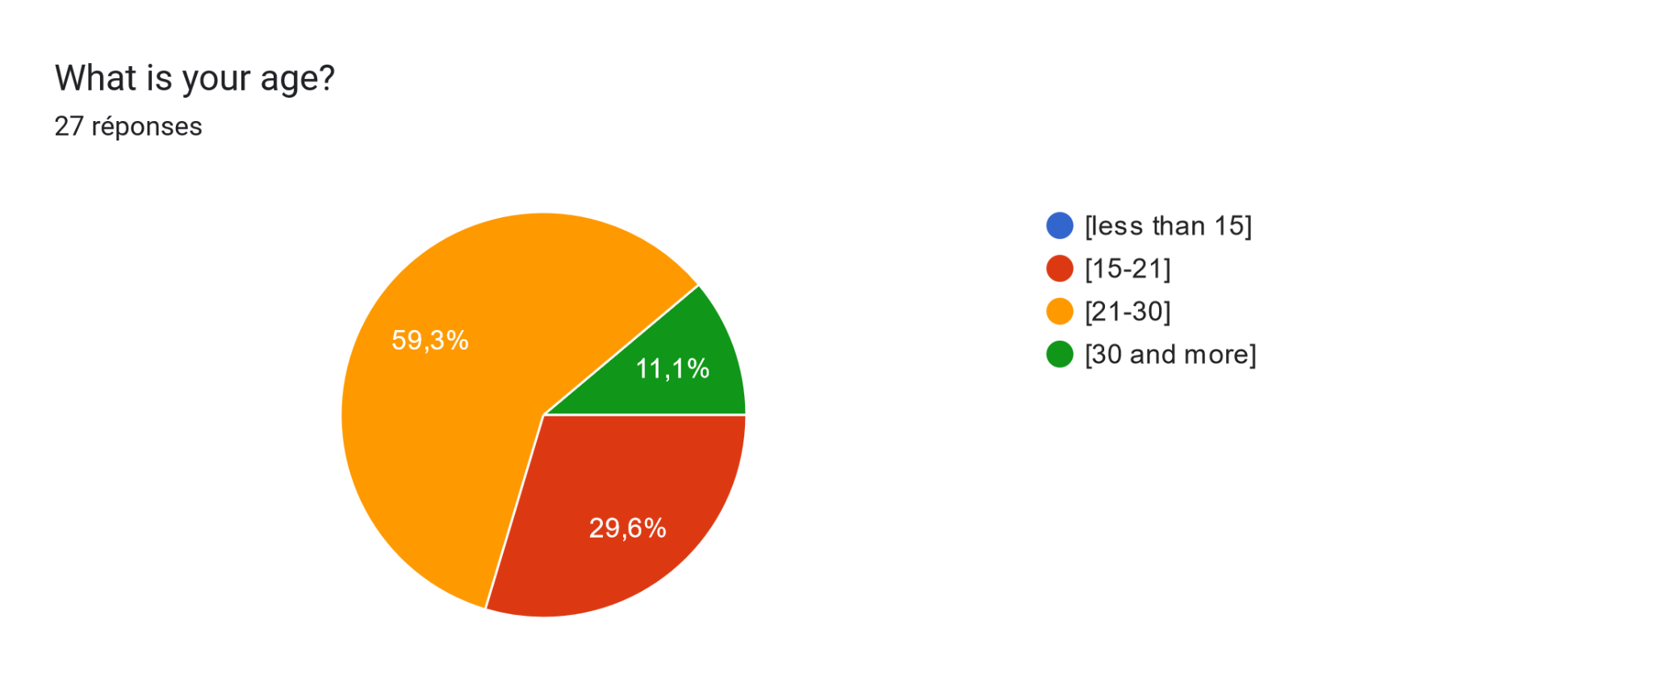

so the majority atre the person between [21-30]

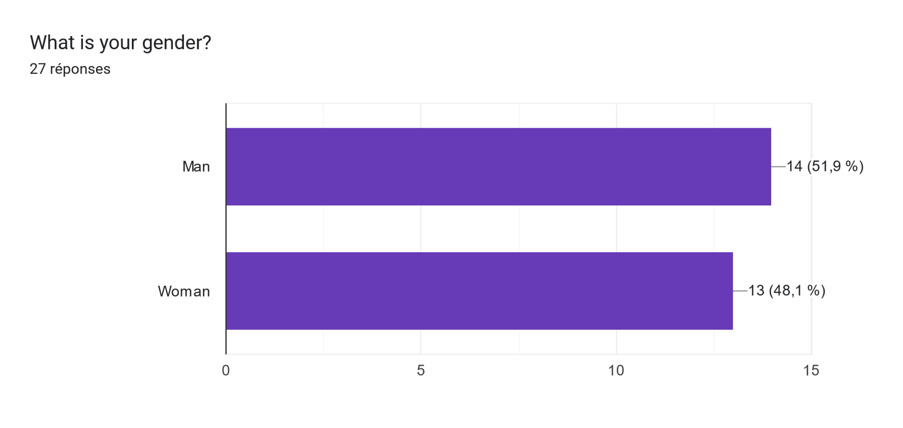

Tableau des réponses au formulaire Forms. Titre de la question : How often do you misplace or lose important items?
. Nombre de réponses : 27 réponses.

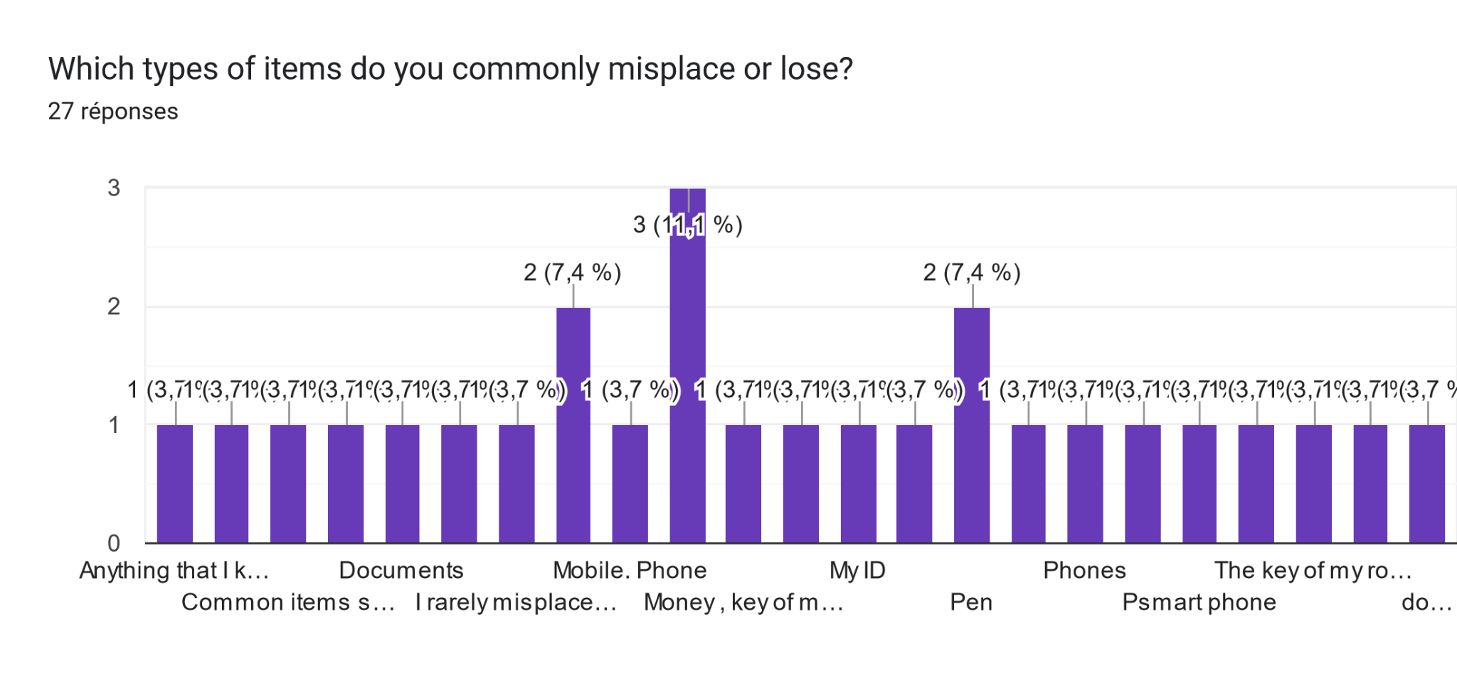

Tableau des réponses au formulaire Forms. Titre de la question : Which method have you  use to find this items ?
. Nombre de réponses : 27 réponses.

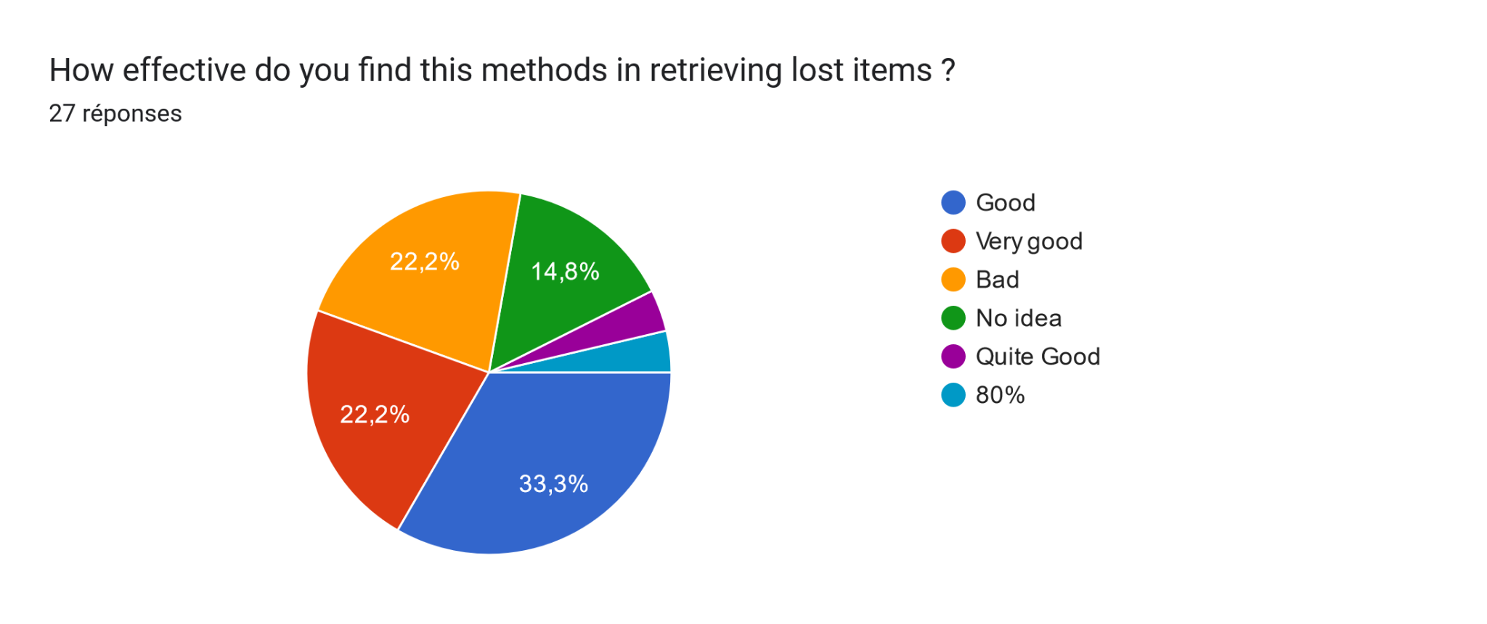

Tableau des réponses au formulaire Forms. Titre de la question : Do you want to have a mobile App to found your items ?
. Nombre de réponses : 24 réponses.

Tableau des réponses au formulaire Forms. Titre de la question : Are you  concerned about the privacy and security of your data while using a such App ?
. Nombre de réponses : 27 réponses.

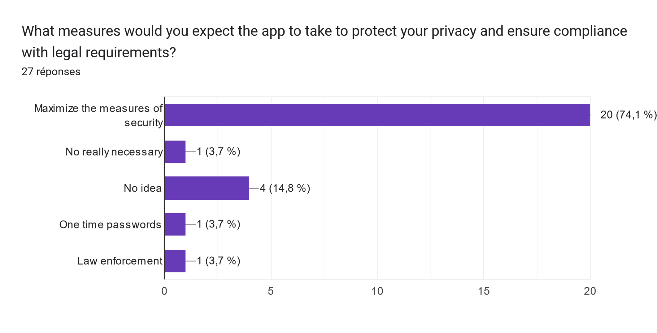

* Concerning the person who found an items

Tableau des réponses au formulaire Forms. Titre de la question : Have you ever found a lost item and successfully returned it to its owner?
. Nombre de réponses : 27 réponses.

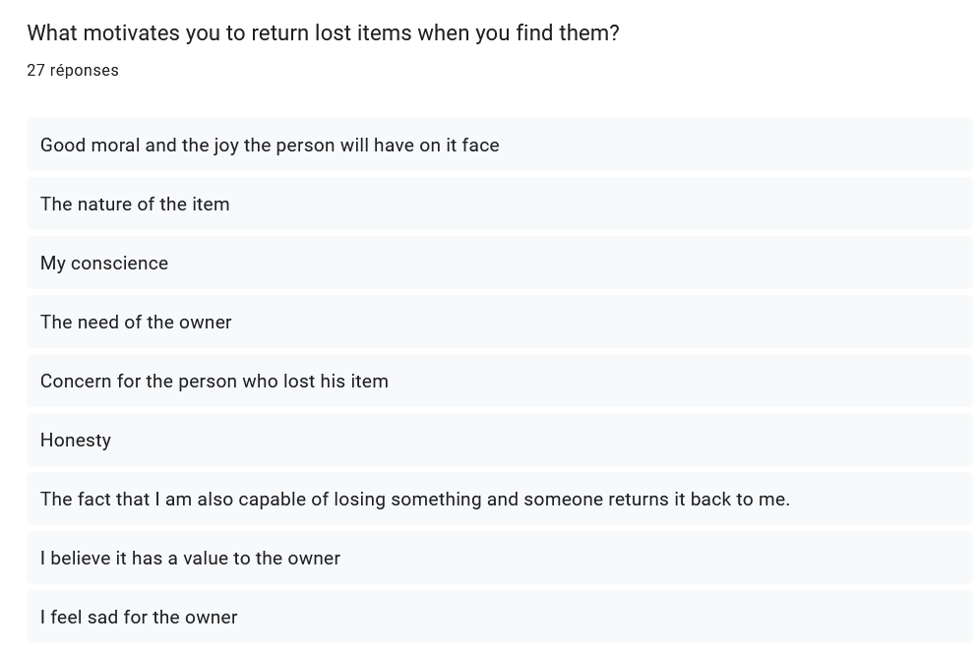

Tableau des réponses au formulaire Forms. Titre de la question : How often do you come across lost items in your daily life?
. Nombre de réponses : 27 réponses.

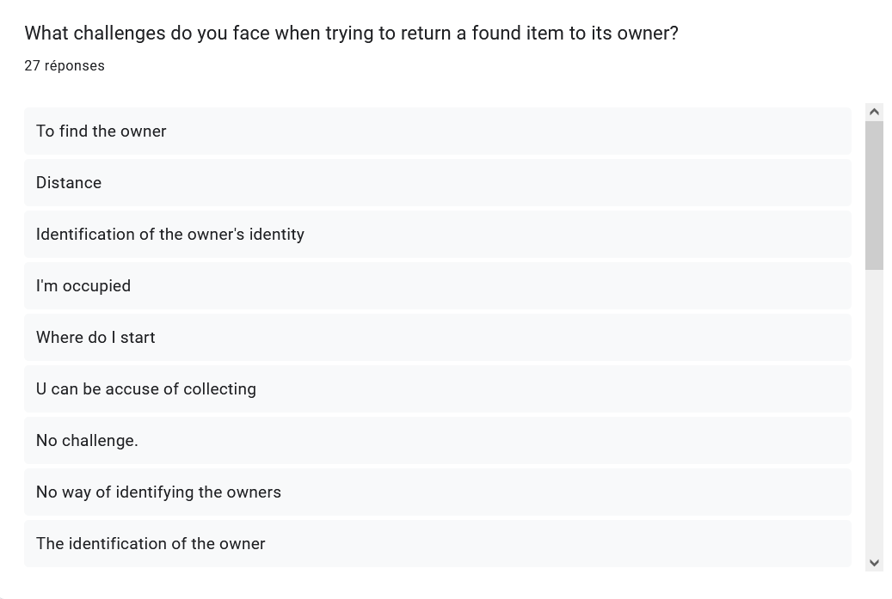

Tableau des réponses au formulaire Forms. Titre de la question : Would you be willing to use a mobile app to help identify the owner of a lost item through image matching?
. Nombre de réponses : 26 réponses.

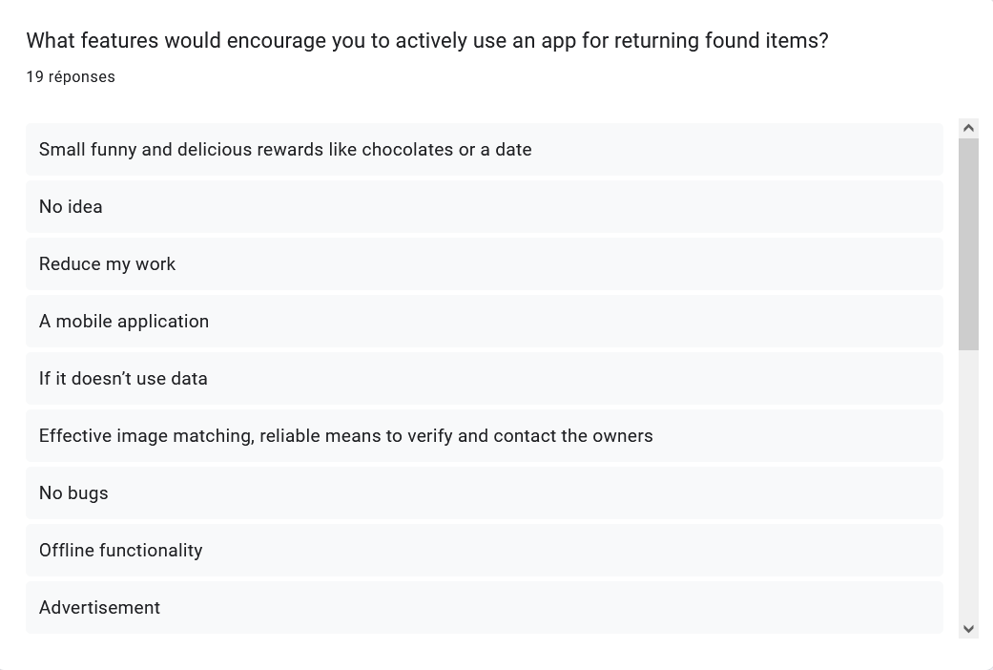

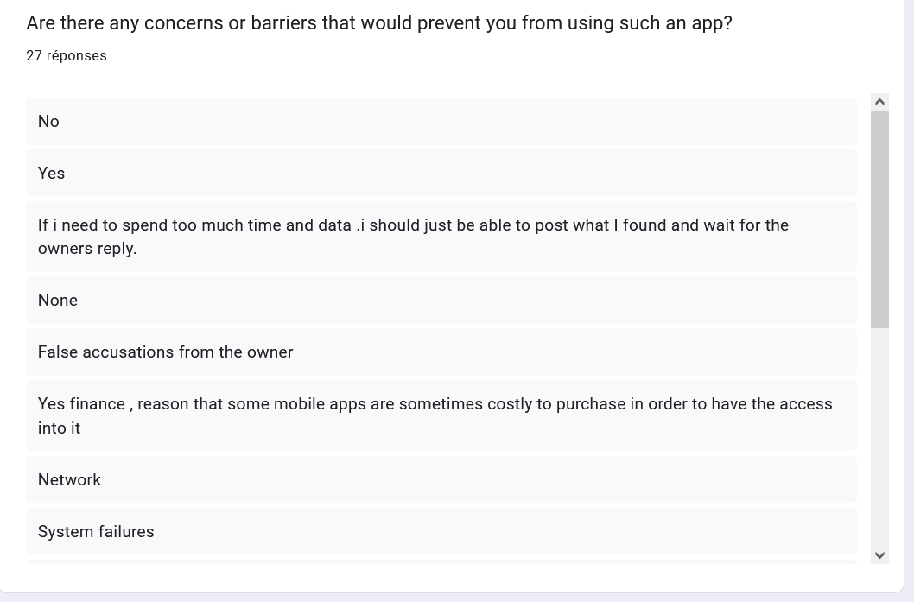

Tableau des réponses au formulaire Forms. Titre de la question : How important is it for you to have a reliable and secure method to connect with the owner of a lost item?
. Nombre de réponses : 26 réponses.

Tableau des réponses au formulaire Forms. Titre de la question : Would you prefer to remain anonymous when returning a found item, or are you open to communication with the owner?
. Nombre de réponses : 26 réponses.

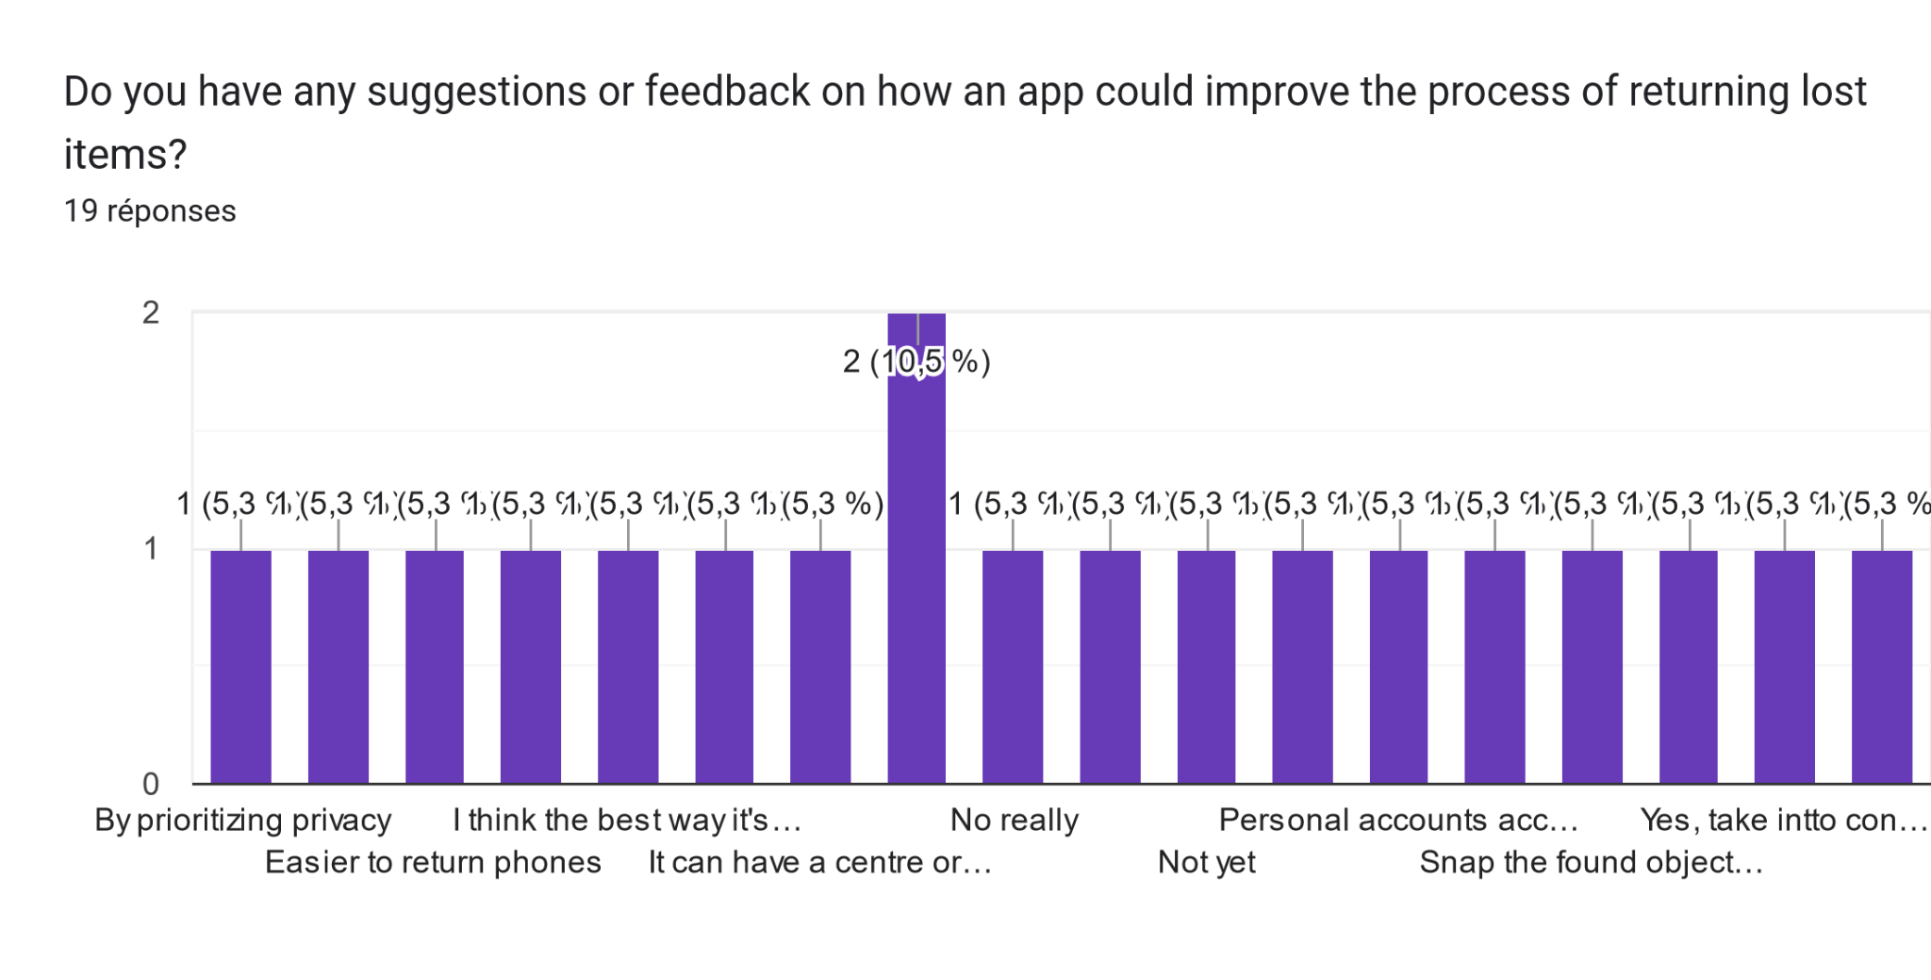

Conducting detailed interviews and online survey with people who have experienced losing items, we found out that the following objects are commonly lost by people in our community:

* Personal Documents like National Identification Cards, Passports, Driver’s license, Credit Cards, Certificates.
* Personal electronics like phones, laptops and tablets.
* School Items like textbooks and school books.
* Wallets and Purses.
* House and car keys.
* Jewelry and Watches.

The loss of these items often prompts the need for systems that can help in their quick retrieval to minimize inconvenience or the potential for theft.

## COMPETITOR ANALYSIS

Conducting a competitor analysis for requirement gathering in the development of a mobile-based application for archival and retrieval of missing objects using image matching involves systematically reviewing existing documentation and sources relevant to our project. This method helps to understand current capabilities, identify gaps, and define the scope of new system requirements based on learned information. We studied some existing systems and we identified the following gaps:

### EXISTING SYSTEMS LIMITATIONS

▪ Manual Matching: In some systems, users must manually browse and compare lost and found listings, which can be time-consuming and inefficient.

▪ Low Recovery Rates: The effectiveness of these apps often depends on the user base size and engagement, leading to potentially low recovery rates.

▪ Limited Search Capabilities: in some systems, Search functions are often basic, relying on text descriptions without utilizing more advanced filtering or matching technologies.

### IMAGE MATCHING TECHNOGOGIES:

Explore image matching technologies available and decide on the most suitable options based on performance, accuracy, and cost. From our document analysis, we came out with four image matching technologies which will be describes below:

#### FEATURE BASED MATCHING

This method involves detecting key features (like edges, corners and others) in images, describing these features in a way that is invariant to scaling, orientation, and lighting conditions, and then matching these features between different images.

* Highly accurate and effective in varied conditions.
* Can be computationally intensive, which might affect performance on mobile devices unless optimized.
* Tools/Algorithms: SIFT (Scale-Invariant Feature Transform), SURF (Speeded Up Robust Features), ORB (Oriented FAST and Rotated BRIEF).

#### HASHING TECHNIQUE

Image hashing involves converting images into compact digital "hashes" that can be quickly compared. Changes to the image result in changes to the hash, but similar images produce similar hashes.

* Extremely fast comparison times and low memory requirements.
* Sensitivity to image modifications.
* can vary minor changes and can sometimes produce different hashes.
* Tools: pHash (Perceptual hashing), dHash (Difference hashing).

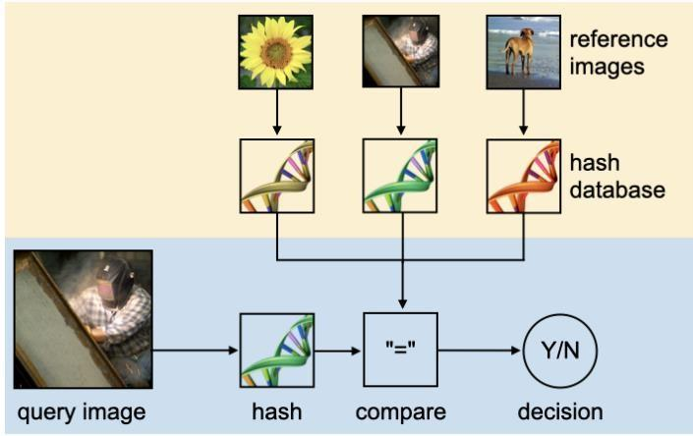

*Figure 2: an overview of image Hashing*

#### TEMPLATE MATCHING

Template matching works by sliding a template image over a source image to determine if the template matches a portion of the source image.

* Simple and easy to implement.
* Not robust to changes in scale or rotation, and can be inefficient if the template size and the source image size are large.
* Best for scenarios where objects have a standard orientation and size.

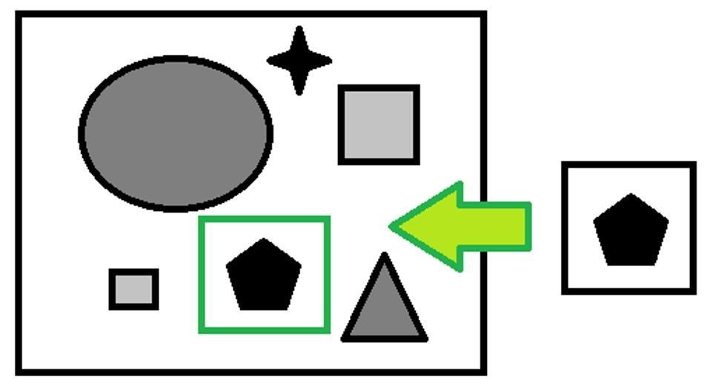

*Figure 3: an overview of template matching*

#### HISTOGRAM COMPARISM

This technique compares the color histograms of two images. If the histograms are similar enough based on a defined threshold, the images are considered a match.

* Fast and not affected by image size or orientation.
* Can fail if the image backgrounds are different or if the color distribution overlaps significantly despite the images being different.
* Useful when color distribution is a reliable identifier.

### STAKEHOLDERS NEEDS AND EXPECTATIONS

From our various requirement gathering technique, we came out with the following stakeholder’s need and expectation:

* **User-Friendly Interface:** Users expect a simple, intuitive interface that makes uploading images, searching for items, and navigating the app straightforward.
* **Accuracy of Image Matching**: High accuracy in matching found objects with lost items to ensure users can reliably recover their belongings.
* **Speed:** Quick responses and fast loading times, especially when uploading images and receiving match results.
* **Privacy and Security:** Robust protection of personal data, including images and contact information. Users want assurance that their information is secure and privacy is respected.
* **Accessibility:** The app should be accessible to users of all abilities, including provisions for those with visual or motor impairments.
* **Notifications and Updates:** Timely notifications about potential matches and updates on their lost or found items.
* **Support and Help:** Easy access to customer support in case of issues or questions regarding the app’s use.

# SYSTEM REQUIREMENT

The system requirements for designing and implementing a mobile application focused on archival and retrieval of missing objects using image matching technology encompass both functional and non-functional aspects. These requirements will guide the development process, ensuring the application meets its intended purpose effectively and efficiently. Here’s a breakdown of these requirements:

## FUNCTIONAL REQUIREMENT

Functional requirements describe what the system should do. They detail the behaviors and functions the application must support. These include:

▪ **User Registration and Authentication**: Users can create, manage, and delete accounts.

▪ Image Upload and Storage: Users can upload images of missing or found objects.

▪ **Image Matching Functionality:** Implement advanced image matching algorithms to compare uploaded images against the database. Automatically notify users of potential matches.

▪ **User Notification:** Real-time notifications for users when a potential match is found. Notifications for system updates or important information.

▪ **Search and Filtering Option:** Allow users to search the database using various filters (date, location, type of object). Intuitive user interface for easy navigation and use.

▪ **User Interaction and Communication:** Enable secure messaging or contact methods between users to discuss potential matches. Privacy controls to manage what information is visible to other users.

▪ **Reporting and Management Tools:** Tools for users to report issues or give feedback. Administrative tools for managing the system, user activities, and data.

## NON FUCTIONAL REQUIREMENT

Non-functional requirements specify how the system performs certain tasks and under what constraints. They are critical for ensuring the usability, reliability, and performance of the application:

▪ **Performance:** The application should load and respond quickly, even under high user load.

▪ **Scalability:** The system must be scalable to accommodate a growing number of users and data entries. Efficient data handling and storage solutions to manage large volumes of images.

▪ **Security:** Robust data encryption for storing and transmitting user data and images. Compliance with data protection regulations (e.g., GDPR, CCPA) to ensure user privacy.

▪ **Usability:** The application should be user-friendly, with a clean and intuitive interface suitable for varied demographics. Accessibility features to cater to users with disabilities.

▪ **Reliability:** High availability of the application with minimal downtime. Maintainability: The system should be easy to update and maintain.

▪ **Compatibility:** The application should be compatible across multiple mobile platforms (iOS and Android) and ensure good performance across various device models and screen sizes.

By meticulously defining both functional and non-functional requirements, you can ensure that the mobile application for archival and retrieval of missing objects using image matching is developed to meet both user expectations and technical standards. This foundational work is key to creating a successful and widely adopted application.

# IMPORTANCE OF REQUIREMENT GATHERING

* **Clarifies User Needs:** Ensures the product meets actual user expectations and solves the right problems.
* **Defines Project Scope:** Helps in accurately defining what needs to be done, preventing scope creep and ensuring effective resource allocation.
* **Reduces Costs:** Minimizes the likelihood of expensive changes and rework later in the development process by clarifying requirements upfront.
* **Improves Efficiency:** Provides developers and project managers with a clear roadmap, streamlining the development process and reducing time to market.
* **Enhances Communication**: Fosters better understanding and cooperation among all stakeholders, including developers, clients, and end-users.
* **Increases Success Rate:** Detailed requirements lead to higher quality outputs and greater satisfaction, enhancing the overall success of the project.

# CONCLUSION

The requirement gathering phase is pivotal in setting the foundation for a successful project. By systematically collecting and analyzing the needs and expectations of all stakeholders, this phase ensures that the project is precisely aligned with user requirements and business objectives. Effective requirement gathering not only clarifies the project scope and facilitates efficient resource allocation but also minimizes risks and reduces the need for costly revisions later in the development process. Ultimately, investing in thorough requirement gathering enhances communication among stakeholders, streamlines the development workflow, and significantly increases the likelihood of project success.

# REFERENCES

1. M. Ghazal, F. Haneefa, S. Ali, Y. Alkhalil and E. Rashed, "Mobile-Based Archival and Retrieval of Missing Objects Using Image Matching," 2015 3rd International Conference on Future Internet of Things and Cloud, Rome, Italy, 2015,
2. [https://www.researchgate.net/figure/An-overview-of-image-hashing-consistingof-two-primary-stages-1-an-offline-stage_fig1_355764637](https://www.researchgate.net/figure/An-overview-of-image-hashing-consisting-of-two-primary-stages-1-an-offline-stage_fig1_355764637) (Accessed, 24 April 2024)
3. [https://www.repo.unihannover.de/bitstream/handle/123456789/14634/Feature _detection_and_description.pdf?sequence=1](https://www.repo.unihannover.de/bitstream/handle/123456789/14634/Feature_detection_and_description.pdf?sequence=1) (Accessed, 24 April 2024)
4. [https://www.researchgate.net/figure/An-overview-of-image-hashing-consistingof-two-primary-stages-1-an-offline-stage_fig1_355764637](https://www.researchgate.net/figure/An-overview-of-image-hashing-consisting-of-two-primary-stages-1-an-offline-stage_fig1_355764637)  (Accessed, 24 April 2024)
5. <https://ilost.co/> (Accessed on, April 27)
6. <https://joinfoundhero.com/> (Accessed on, April 27)
7. <https://www.findmylost.it/> (Accessed on, April 27)